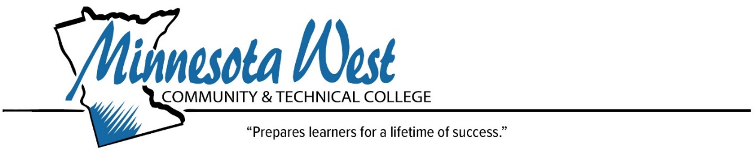
Procedure Information
Number: Click or tap here to enter text.
Author: Click or tap here to enter text.
Effective Date: Click or tap here to enter text.
Next Review Date: Click or tap here to enter text.

Regulatory Authority
Minnesota State Board Procedure: Click or tap here to enter text.
Web address: Click or tap here to enter text.
Procedure:

